 | COSHH Risk Assessment No: XXXXX  Product Name: xxxxx |  |  |  |  |  |  |  |  |  |  |  |  |  | INSERT LOGO
Company name: |  |  |  |  |  |  |  |  | Dept. (if applicable):
Describe the activity or work process.
(Inc. how long/ how often this is carried out and quantity substance used)
Location of process being carried out?
Identify the persons at risk: |  |  |  |  | Employees |  |  |  |  | Sub-contractors |  |  |  | Public
Name the substance involved in the process and its manufacturer.
(A copy of a current safety data sheet is attached to this assessment)
Classification (state the category of danger)
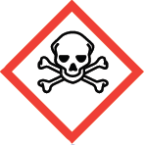 | Toxic |  |  | 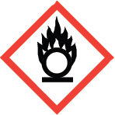 |  | Oxidising |  |  |  |  |  |  | Gas Under Pressure
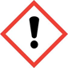 | Harmful/ Irritant |  |  | 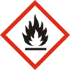 |  | Flammable |  |  |  |  |  |  | Carcinogen
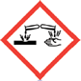 | Corrosive |  |  | 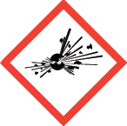 |  | Explosives |  |  |  |  |  |  | Dangerous for  the environment
Hazard Type
Gas Vapour Mist Fume Dust Liquid Solid Other (State)
Route of Exposure

Inhalation Skin Eyes Ingestion Other (State)
Workplace Exposure Limits (WELs) please indicate n/a where not applicable
State the Risks to Health from Identified Hazards
Control Measures:
Is health surveillance or monitoring required?

Yes No
Personal Protective Equipment (state type and standard)
Dust mask |  |  |  |  |  | Visor |  |  |  |  | Suitable for chemical splashes
Respirator |  |  |  |  |  | Goggles
Gloves |  |  |  |  |  | Overalls
Footwear |  |  |  |  |  | Other
First Aid Measures
Storage
Disposal of Substances & Contaminated Containers
Hazardous Waste Skip Return to Depot Return to Supplier Other

(If Other Please State):
Is exposure adequately controlled? |  |  |  |  |  |  | Yes No
Risk Rating Following Control Measures
High Medium Low

Assessed by: xxxx Date: xxxx Review Date: xxxx

